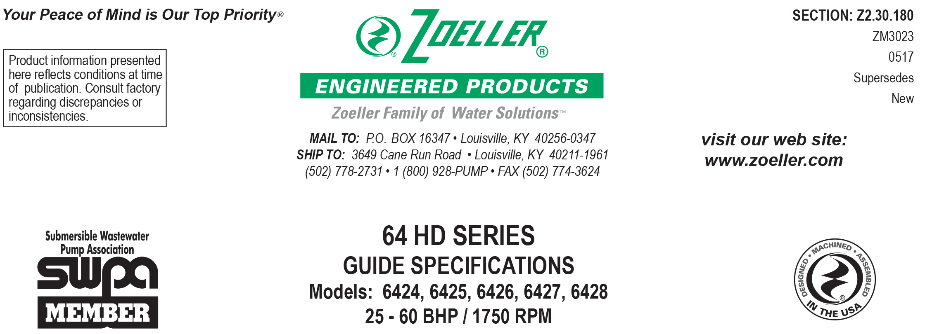

1.01 GENERAL
Contractor shall furnish all labor, material, equipment and incidentals required to provide _____ (QTY.) non-clog submersible centrifugal sewage pump (s) as specified herein.

2.01 OPERATING CONDITIONS
Each submersible pump shall be rated at _______ BHP, _______ volts, _____ phase, _____ Hz, 1725 RPM. The unit shall produce
_______ GPM at _______ feet of TDH.

The submersible pump shall be non-overloading throughout the length of the curve and be capable of operating continuously partially submerged without damaging the pump.

The submersible pump shall handle the solids found in wastewater collection systems. The submitted performance curve shall show, in addition to the head and flow performance, hydraulic efficiency, and motor rating curves. The curve data shall be per the SWPA (Submersible Wastewater Pump Assoc.) approved curve format.

The pump housing shall have a:
_____ 4" flanged discharge passing a 3.125" spherical solid
(or)
_____ 6" flanged discharge passing a 4" spherical solid

3.01 CONSTRUCTION
Each pump shall be of the close coupled Model _________ submersible type as manufactured by Zoeller Engineered Products of Louisville, Ky. (800-928-7867). The castings shall be constructed of epoxy coated class 30 cast iron. The SS motor housing shall be oil-filled to dissipate heat and enable the unit to operate for continuous duty without damage to the motor. All external-mating parts shall be machined and sealed with a Buna-N square ring. All fasteners exposed to the liquid shall be 300 series stainless steel. The motor shall be protected on the top side with a compression fitted buna-n grommet with individually spliced cord leads which prevents moisture wicking into the motor housing. The motor shall be protected by two independent mechanical seals, each having a separate spring assembly. The oil-filled seal chamber located between the two mechanical seals shall contain 2 probes to detect seal leakage. The upper and lower ball bearings shall be capable of handling all radial and thrust loads. The pump housing shall be of the concentric design thereby equalizing the pressure forces inside the housing, which will extend the service life of the seals and bearings. The top pump shall have integral SS lifting lugs.

4.01 ELECTRICAL POWER CORD
The pump shall be supplied with ____ 25’ or ____ 50’ of multiconductor power cord. It shall be SO type cord capable of continued exposure to the pumped liquid sized for the rated full load amp loading of the pump in accordance with the National Electrical Code. Anti-wicking control shall be provided by an insulated and molded Buna-N grommet, which is compression, fitted and clamped to the motor housing. Inside the grommet will be individually spliced wire leads isolated to prevent leakage into the motor housing.

5.01 MOTOR
The oil-filled motor shall be a Class F insulated NEMA B design rated for continuous duty. At maximum load, the winding temperature will not exceed 250 degrees F unsubmerged. Since air-filled motors are not capable of dissipating heat, they shall not be considered equal. Bimetallic thermal sensors shall be located in the motor windings.

_____ Provide an optional Inverter Duty motor for applications using a VFD controller, for 30-60 Hz speed range, pulse width modulated, variable torque, meeting NEMA MG-1 Part 30.

6.01 BEARINGS AND SHAFT
Upper and lower ball bearings made of high carbon chromium steel shall be provided to prevent shaft deflection by withstanding all thrust and radial loads. The motor shaft shall be made of 416 SS and have a minimum diameter of 1.875”.

7.01 SEALS
Pump shall have a dual mechanical seal configuration with the seals mounted in tandem. Each seal assembly having carbon rotary and ceramic stationary faces with Buna-N elastomer and 316 SS spring. It shall be equal to a Crane Type 21 configuration. Double seals with a common intermediate spring shall not be considered equal.

Optional seal faces shall be
___silicon carbide / silicon carbide ____ Lower / ____ Upper.
___tungsten carbide / tungsten carbide ____ Lower / ____ Upper.

8.01 IMPELLER
The impeller shall be a fully balanced 2-vane enclosed design made from ductile iron and capable of passing solids found in wastewater. It shall have pump out vanes located on the back shroud to keep debris away from the seal area. It is to be keyed and bolted to the a tapered shaft. Attempts to improve efficiency by coating impeller shall not be allowed.

Optional impeller design shall be _____" impeller trim — _____ G.P.M. @ _____ feet of T.D.H.

9.01 PAINTING
The pump shall have a corrosion resistant baked on epoxy powder coating on all exterior cast surfaces.

____Optional coating shall be double epoxy finish protecting all castings coming in contact with the liquid.

10.01 SERVICEABILITY
Components required for the repair of the pump shall be readily available. Components such as mechanical seals and bearings shall not be of a proprietary design and be available from local industrial supply houses. Special tools shall not be required to service the pump. A network of Authorized Warranty and Customer Care Centers shall be available nationwide.

11.01 SUPPORT
The pump shall have support legs enabling it to be a freestanding unit. The legs will be adjustable but high enough to allow solids to flow into the housing. Legs to be removed if pump is used with rail system.

For those situations where a freestanding unit is not desired, the following support components are available.
____Rail system with pump suspended from a base elbow by means of a sealed pump plate attached to the pump. Rail and guide brackets shall be SS. Rail pipes and lifting cables are to be provided by others.
____SS intermediate stabilizer required for rail systems used where basin depths are greater than 12 feet.

12.01 TESTING
Each pump shall have a 20 - 30 minute operational test before shipment. The test shall be conducted with the pump submerged in a tank thereby duplicating its actual performance. A computer-generated report shall be available following this test. The report will show pump performance, amp draws, efficiencies and power consumption at various performance points for each pump supplied.

____An optional certified test based on the Hydraulic Institute or SWPA (Submersible Wastewater Pump Association) Test Standard for submersible pumps.
____Start up services at the job site by an authorized representative of Zoeller Engineered Products shall be required. Start-up report form ZM1074 should be completed in the presence of the installers and returned to the Project Engineer or Zoeller Engineered Products.

13.01 WARRANTY
Standard warranty shall be 12 months from date of installation or 18 months from date of manufacture, whichever comes first. Additionally, upon receipt and approval of a start up report, a prorated warranty for permanent municipal wastewater lift station installations shall be in effect for up to 60 months or 10,000 hours of operation, whichever comes first. anufacture, whichever comes first.

