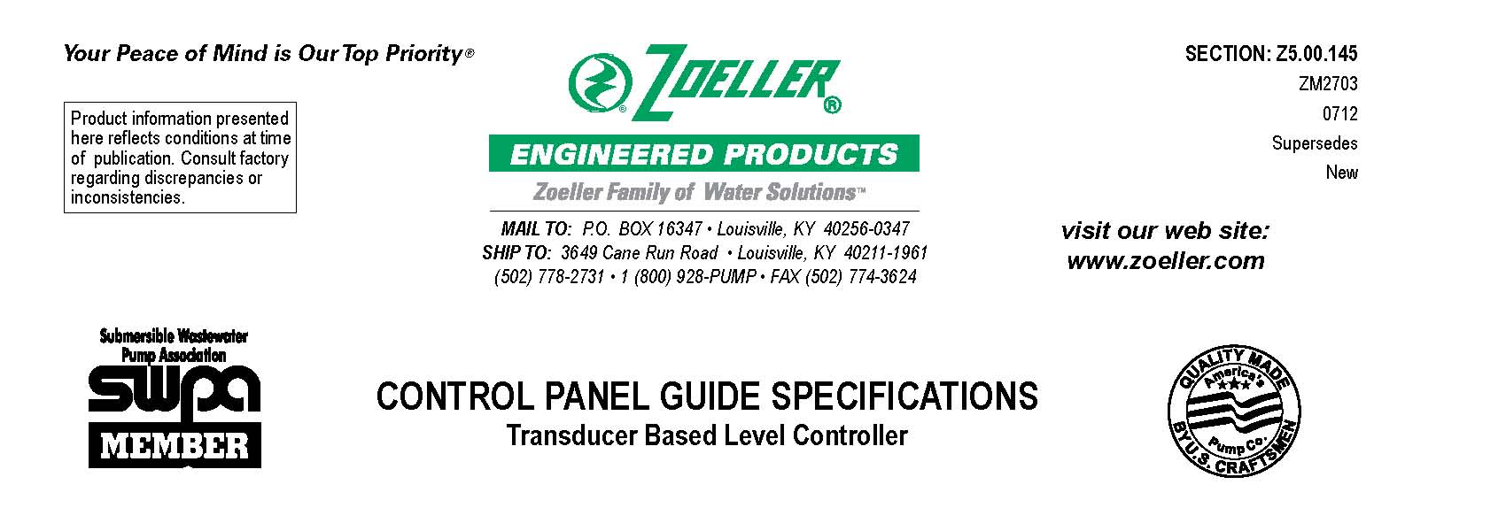

1.01
GENERAL
Contractor shall furnish all labor, materials, equipment and incidentals required to provide a UL listed control panel with a transducer level control and compatible with the submersible pump(s) specified. The control panel shall be assembled and tested by a supplier meeting UL Standard 508 for industrial controls.
The manufacturer supplying the submersible pump shall supply the control panel so as to insure compatibility and assurance in matching the proper panel and features with the pump being supplied and to assure single source responsibility for the equipment supplied.

2.01

CONSTRUCTION
The control panel shall be housed in a NEMA 4X fiberglass enclosure with a dead front and inner door. The panel will include all the components required to operate and protect the pump, high and low water alarm circuitry and a viewable level control system that operates from a 4 – 20 mA input signal from a submersible pressure transducer. A provision shall be available for installing high water and low level float switches for back-up purposes.
An IEC rated starter will include a motor protective switch, IEC rated contactor and overload protection for each pump. The sensors from each pump will connect to the seal leak and thermal cut-out protective circuits in the panel. The high water alarm circuit will include a visible and audible alarm and a dry contact for remote monitoring. The control circuit will operate off of 120 volts.
Mounted on the inner door will be the level controller, pilot lights and selector switches. The level controller shall have an alpha-numeric display and a 20 segment LED bar graph. There shall be two red 22 mm oil-tight pilot lights on the inner door, one for high level and the other for low level. There will be a 22 mm oil tight Hand-Off-Auto selector switch for each pump, an alarm test and an alarm reset push button switch on the inner door.
The level controller shall be a user friendly touch pad and display with a 4 – 20 mA input from the transducer with configurable zero and span. The unit of measure shall be configurable to feet, inches and percentage or metric. The 20 segment bar graph will display the current liquid level in the wet well. The controller can be programmed up to six level set points. The controller shall also provide pump over temperature, seal leak and high or low water level conditions. Elapsed time meters, cycle counters, lag pump delay and an alternator selector switch shall also be incorporated into the controller.

3.01
OPTIONS
_____ Flashing high water alarm beacon
_____ Pump run dry contact for remote monitoring
_____ Low water alarm dry contact for remote monitoring
_____ Lightning arrestor to protect the system against electrical surges
_____ Anti-condensation heater to prevent the build up of moisture inside the enclosure
_____ Phase monitor for three phase motor protection
_____ Intrinsically safe relays for the two float switches when in a Class I Division 1 Group C & D classified area
_____ Automatic-Reversing circuits utilized in conjunction with bi-directional grinder pumps
_____ NEMA 3R steel enclosure
_____ NEMA 4X SS enclosure
© Copyright 2012 Zoeller Co. All rights reserved.

4.01
LEVEL TRANSDUCER
Provide a UL, CSA, and FM certified submersible level transducer. The transducer shall be non-clogging with a stainless steel housing, teflon-coated diaphragm and rated for wastewater application. The transducer shall have a 4-20 mA output with a 6 psi (13.8’) operating range and a 40’ vented #22-4 polyurethane cable jacket. The transducer shall be fitted with a ½” NPT male conduit connecton for mounting onto rigid conduit suspended into the basin.

OPTIONAL: _____ psi operating range

_____ feet of electrical cable

5.01
FLOAT SWITCHES
Provide two UL listed narrow-angle normally open float switches for the back-up high water and low water alarm circuits. Float housing to consist of high-impact corrosion-resistant PVC. The switch shall include an adjustable weight set at a predetermined elevation to activate the alarm circuit. In a Class I Division 1 Group C&D Classified area the switch shall be suitable for intrinsically safe control circuits.
The float switch cable length shall be: _____ 25 feet _____ 35 feet _____ 50 feet

© Copyright 2012 Zoeller Co. All rights reserved.

