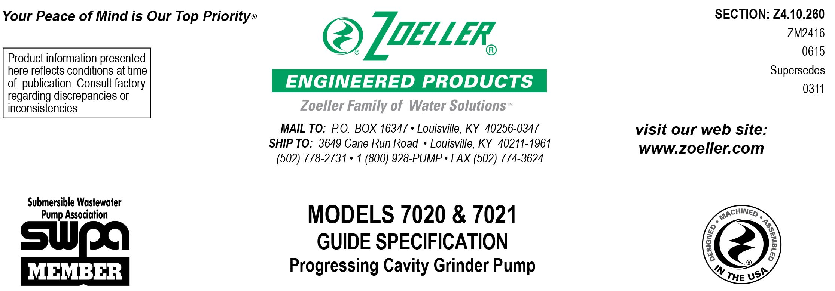

1.01 GENERAL
Contractor shall furnish all labor, material, equipment and incidentals required to provide _____ (QTY.) Model _______progressing cavity grinder pump(s) as specified herein.

2.01 OPERATING CONDITIONS
Each submersible pump shall be rated at _____ 1 H.P./ _____ 2 H.P., 230 volts, single phase, 60 Hz, 1750 R.P.M. The unit shall produce _____ G.P.M. at _____ feet of T.D.H.

The submersible pump shall be capable of handling sewage and grinding it into fine slurry enabling it to be pumped over long distances in pipelines as small as 1.25" in diameter.

The pump shall be controlled with:
____a piggyback float switch with Qwik-Box and remote high water alarm panel.
____a piggyback float switch with remote Plugger Panel with high water alarm.
____a NEMA 4X simplex control panel with 3 float switches and high water alarm.

3.01 CONSTRUCTION
Each progressing cavity grinder pump shall be equal to the model 7020 (1 H.P.) or 7021 (2 H.P.) submersible progressing cavity type grinder pump as manufactured by Zoeller Engineered Products of Louisville, Ky. (800-928-7867). The castings shall be constructed of class 30 cast iron. The motor housing shall be finned and oil-filled to dissipate heat. All external-mating parts shall be machined and sealed with a viton square ring. All fasteners exposed to the liquid shall be 300 series stainless steel. The motor shall be protected in the event of cord damage with a sealed junction chamber which will prevent moisture wicking into the motor housing. The motor shall be protected on the lower side with a single mechanical seal. The upper and lower ball bearings shall be capable of handling all thrust and radial thrust loads. The pump housing shall be of the concentric design thereby equalizing the pressure forces inside the housing, which will extend the service life of the seals and bearings. The pump housing shall incorporate a pressure relief valve to protect the motor from overheating. The pump shall have a SS lifting bracket.

4.01 ELECTRICAL POWER CORD
The submersible pump shall be supplied with 20' (____ 35' or ____ 50' optional) of multiconductor power cord. It shall be SO type cord capable of continued exposure to the pumped liquid. Power cord shall be sized for the rated full load amp loading of the pump in accordance with the National Electrical Code. Power cable shall enter into the junction chamber through a compression type-sealing gland. Water sealing and strain relief are separated. The entire junction chamber shall be sealed off from the motor housing by through wall terminals to protect the motor from moisture.
____Provide prewired conduit and junction box for connecting the pump and float switch cords in a flexible and water tight assembly supplying power to the system. Conduit length shall be ____ 25', ____35' or ____50'.

5.01 MOTOR
The oil-filled motor shall be a Class B insulated NEMA B design rated for continuous duty. At maximum load, the winding temperature will not exceed 220 degrees F unsubmerged. Since air-filled motors are not capable of dissipating heat, they shall not be considered equal. The pump motor shall have an integral thermal overload switch in the windings for protecting the motor. Bimetallic thermal sensors are not acceptable. The capacitor circuit shall be mounted internally in the pump’s integral junction chamber.

6.01 BEARINGS AND SHAFT
Upper and lower ball bearings made of high carbon chromium steel shall be provided to prevent shaft deflection by withstanding all thrust and radial loads. The bearing system shall be designed to enable proper cutter alignments from shut off head to maximum load at 5 feet of TDH. The motor shaft shall be made of 416 SS and have a minimum diameter of .750".

7.01 SEALS
Pump shall have a single mechanical seal protecting the motor from the pumped liquid, seal assembly having carbon stationary and ceramic rotary faces with Buna-N elastomer and 316 SS spring. It shall be equal to a Crane Type 6a configuration.
8.01 HYDRAULIC ROTOR AND STATOR
The hydraulic rotor shall be a precision machined, highly polished, helix design made of hardened 304 SS. The hydraulic stator shall be a helix design made from an injection molded, abrasion resistant Buna-N elastomer. The geometry of these two interacting parts will result in a double string of sealing cavities - formed when the rotor turns inside the stator. The cavities progress axially from the inlet to the outlet conveying the fluid.

8.02 CUTTER MECHANISM
The cutter and plate shall be constructed of 440C SS with a Rockwell C hardness of 55 - 60. The stationary cutter plate shall have specially designed orifices machined through it which enable the slurry to flow through the pump housing at an equalized pressure and velocity. The rotating “star” cutter design shall have double-sided cutting blades. Cutter designs incorporating close tolerance and those that grind on the outside circumference of the rotary plate shall not be considered equal.

9.01 PAINTING
The exterior castings of the pump shall be protected with green powder coated epoxy finish.

10.01 SERVICEABILITY
Components required for the repair of the pump shall be readily available within 24 hours. Components such as mechanical seals and bearings shall not be of a proprietary design and be available from local industrial supply houses. Special tools shall not be required to service the pump. A network of service stations shall be available nationwide in those cases where service requirements are beyond the scope of in-house service mechanics.

11.01 SUPPORT
The pump shall have stainless steel support legs enabling it to be a free standing unit. The legs will be high enough to allow solids and long stringy debris to enter the cutter assembly.

For those “Outdoor” installations requiring a factory assembled basin package:
____Simplex system with a ____" diameter by ____" depth basin used with the square guide rail system.
____Simplex system with a ____" diameter by ____" depth basin used with the flex-hose disconnect system.

For those “Indoor” installations requiring a factory assembled basin package:
____Simplex system with a ____" diameter by ____" depth basin.

For those installations requiring a field assembled system:
____The pump shall be installed with a square guide rail system, in a ____" deep basin.
____The pump shall be installed with a flex-hose disconnect system.

12.01 TESTING
Each pump shall be operated and tested in liquid during its production process. It shall be checked at its maximum running point for performance, amps, grounding, winding insulation, and water tightness.

____An optional certified test based on the Hydraulic Institute or SWPA (Submersible Wastewater Pump Association) Test Standard for submersible pumps.

____Start up services at the job site by an authorized representative of Zoeller Engineered Products shall be required. Start-up report form ZM1074 should be completed in the presence of the installers and returned to the Project Engineer or Zoeller Engineered Products.

13.01 WARRANTY
Standard warranty shall be 12 months from date of installation or 18 months from date of manufacture, whichever comes first.

