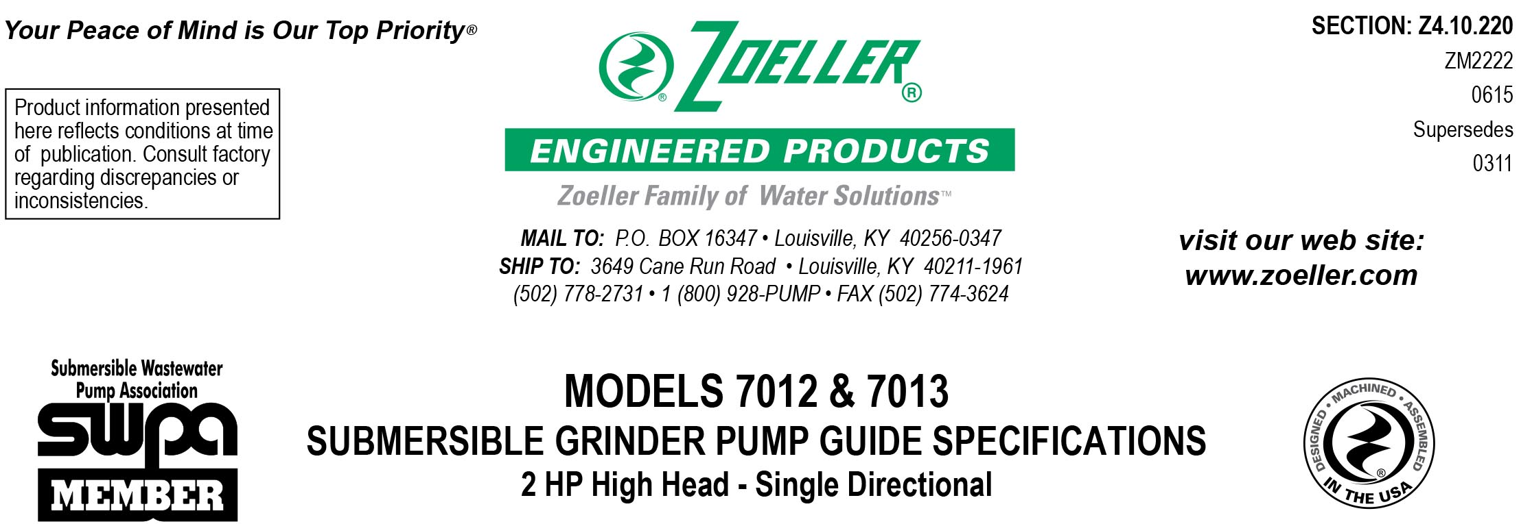

1.01 GENERAL

Contractor shall furnish all labor, material, equipment and incidentals required to provide _____ (QTY.) Model _______centrifugal grinder pump(s) as specified herein.

2.01 OPERATING CONDITIONS
Each submersible pump shall be rated at 2 HP, _______ volts, _____ phase, _____ HZ., 3450 R.P.M. The unit shall produce _______ G.P.M. at _______ feet of T.D.H.

The submersible pump shall be capable of handling sanitary sewage and grinding it into fine slurry enabling it to be pumped over long distances in pipelines as small as 1.25" in diameter.

3.01 CONSTRUCTION
Each centrifugal grinder pump shall be equal to the cCSAus Certified model 7012 High Head or 7013 High Flow submersible type as manufactured by Zoeller Engineered Products of Louisville, Ky. (800-928-7867). The castings shall be constructed of class 30 cast iron. The motor housing shall be finned and oil-filled to dissipate heat. Air-filled motors shall not be considered equal since they do not properly dissipate heat from the motor. All external-mating parts shall be machined and sealed with a viton square ring. All fasteners exposed to the liquid shall be 300 series stainless steel. The motor shall be protected on the lower side with a tandem mechanical seal arrangement with each seal having a separate spring assembly. The oil-filled seal chamber located between the two mechanical seals shall contain 2 probes to detect seal leakage. The upper and lower ball bearings shall be capable of handling all thrust loads. The pump housing shall be of the concentric design thereby equalizing the pressure forces inside the housing, which will extend the service life of the seals and bearings. The pump shall have a SS lifting bracket.

4.01 ELECTRICAL POWER CORD
The pump shall be supplied with 20' (____ 35' or ____ 50' optional) of multiconductor power cord. It shall be SO type cord capable of continued exposure to the pumped liquid. Power cord shall be sized for the rated full load amp loading of the pump in accordance with the National Electric Code. Power cable shall enter into the junction box through a compression type-sealing gland. Water sealing and strain relief is separated. The junction chamber shall be sealed off from the motor housing by through wall terminals to protect the motor from moisture.

5.01 MOTOR
The oil-filled motor shall be a Class F insulated NEMA B design. At maximum load, the winding temperature will not exceed 250 degrees F unsubmerged. Since air-filled motors are not capable of dissipating heat, they shall not be considered equal. Single-phase units shall have an integral thermal overload switch in the windings for protecting the motor. Start capacitors and relay shall be mounted externally from the pump in a panel within 50 feet of the pump location. Three phase units shall have a bimetallic thermal sensor and shall use magnetic starters with overload relays in the control panel for further protection.

6.01 BEARINGS AND SHAFT
Upper and lower ball bearings made of high carbon chromium steel shall be provided to prevent shaft deflection by withstanding all thrust and radial loads. The bearing system shall be designed to enable proper cutter alignments from shut off head to maximum load at 5 feet of TDH. The motor shaft shall be made of 416 SS and have a minimum diameter of 1.0".

7.01 SEALS
Pump shall have a dual mechanical seal configuration with the seals mounted in tandem. Each seal assembly having silicon carbide / carbon lower and carbon / ceramic upper faces with Buna-N elastomer and 316 SS spring. It shall be equal to a Crane Type 21 configuration. Double seals with a common intermediate spring and lip seals shall not be considered equal.
Optional seal faces shall be
____Silicon carbide / carbon ____ Upper.
____Silicon carbide / silicon carbide ____ Lower / ____ Upper.

8.01 IMPELLER
The impeller shall be a fully balanced bronze vortex type with pump out vanes on the back shroud to keep debris away from the seal area. It shall be keyed and bolted to the motor shaft.

8.02 CUTTER MECHANISM
The cutter and plate shall be constructed of 440C SS with a Rockwell C hardness of 55 - 60. The stationary cutter plate shall contain multiple machined orifices which enable the slurry to flow into the pump housing at an equalized pressure and velocity. The "star" cutter, rotating at 3450 RPM, shall shear all solids into a small particulate before passing through the small orifices. Because of the extended service life of the "star" cutter, other cutter designs with tight clearances and those that grind on the circumference of the rotary plate shall not be considered equal.

9.01 PAINTING
The exterior castings of the pump shall be protected with green powder coated epoxy finish.

10.01 SERVICEABILITY
Components required for the repair of the pump shall be readily available within 24 hours. Components such as mechanical seals and bearings shall not be of a proprietary design and be available from local industrial supply houses. Special tools shall not be required to service the pump. A network of service stations shall be available nationwide in those cases where service requirements are beyond the scope of in-house service mechanics.

11.01 SUPPORT
The pump shall have cast iron support legs enabling it to be a freestanding unit. The legs will be high enough to allow solids and long stringy debris to enter the cutter assembly.

For those installations requiring a field assembled rail system:
____ Rail system with pump suspended by means of a sealed pump plate attached to the pump. Rail and guide brackets shall be SS. Rail pipes and lifting cables are to be provided by others.
____ SS intermediate stabilizer required for rail systems used where basin depths are greater than 12 feet.

For those “Outdoor” installations requiring a factory assembled basin package:
____ Simplex system with a ______” diameter by ______” depth basin.
____ Duplex system with a ______” diameter by ______” depth basin.

For those “Indoor” installations requiring a factory assembled basin package:
____ Simplex system with a ______” diameter by ______” depth basin.
____ Duplex system with a ______” diameter by ______” depth basin.

12.01 TESTING
Each pump shall be operated and tested in liquid during the production process. It shall be checked at its maximum running point for performance, amps, grounding, winding insulation, and water tightness.

____ An optional certified test based on the Hydraulic Institute or SWPA (Submersible Wastewater Pump Association) Test Standard for submersible pumps.
____ Start up services at the job site by an authorized representative of Zoeller Engineered Products shall be required. Start-up report form ZM1074 should be completed in the presence of the installers and returned to the Project Engineer or Zoeller Engineered Products.

13.01 WARRANTY
Standard warranty shall be 12 months from date of installation or 18 months from date of manufacture, whichever comes first.

