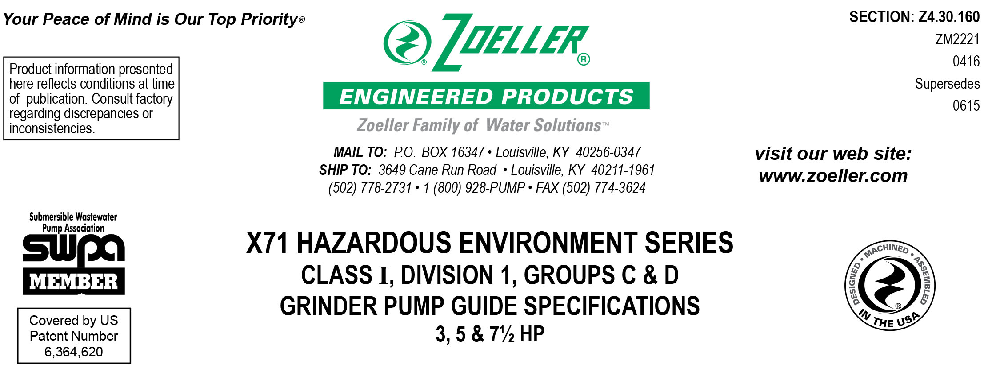

1.01 GENERAL
Contractor shall furnish all labor, material, equipment and incidentals required to provide _____ (QTY.) FM/CSA listed centrifugal grinder pump (s) rated for Class I, Division 1, Group C or D environments as specified herein.

2.01 OPERATING CONDITIONS
Each pump shall be rated at ______ HP, _______ Volts, _____ Phase, _____ Hz, 3450 RPM. The unit shall produce _______ GPM (LPM) at _______ ft (m) of TDH.

The pump shall have a 2½" flanged discharge adaptable to 3" and be capable of handling sanitary sewage and grinding it into a fine slurry enabling it to be pumped over long distances or high vertical lifts in pipelines as small as 2.00" (DN50) in diameter.

____ Optional 2" vertical NPT discharge; High Head and High Flow only.

3.01 CONSTRUCTION
The centrifugal grinder pump shall be equal to the Model _______ submersible type as manufactured by the Zoeller Engineered Products Company of Louisville, Ky. (800-928-7867) and listed by FM and CSA for hazardous environments. The castings shall be constructed of baked on epoxy coated class 30 cast iron. The motor housing shall be finned and oil-filled to dissipate heat and enable the unit to operate unsubmerged without damage to the motor. Air-filled motors shall not be considered equal because of their inability to dissipate heat from the motor. All external-mating parts shall be machined and sealed with a buna-n square ring. All fasteners exposed to the liquid shall be 300 series stainless steel. The motor shall be protected on the top side with an attached sealed junction box chamber which in the event of cord damage will prevent moisture wicking into the motor housing. The motor shall be protected on the lower side with a tandem mechanical seal arrangement with each seal having a separate spring assembly. The upper and lower ball bearings shall be capable of handling all thrust loads. The pump housing shall be of the concentric design thereby equalizing the pressure forces inside the housing, which will extend the service life of the seals and bearings. The top cap shall have cast in lifting lugs. The motor shall be protected by a moisture detection system, which will activate an alarm circuit if liquid is ever present in the upper junction chamber or lower seal cavity. Thermal sensors located in the oil-filled motor housing shall provide temperature protection.

____ As an option, provide the automatic reversing feature, available for flanged discharge 3 phase models, that enables the pump to grind in both CW and CCW direction. This feature prevents clogs and extends cutter life, which will prevent system downtime and extend the service life of the pump.
____ Optional viton square ring seals

4.01 ELECTRICAL POWER CORD
The pump shall be supplied with 25' (7.6 m) [____ 50' (15.2 m) optional] of multiconductor power cord. It shall be SOOW type cord capable of continued exposure to the pumped liquid. Power cord shall be sized for the rated full load amp rating of the pump in accordance with the National Electrical Code. Power cable shall enter into the junction chamber through a compression type-sealing gland. Water sealing and strain relief is separated. Each individual conductor shall be sealed against wicking should the cable become damaged. The entire junction chamber shall be sealed off from the motor housing. The junction chamber shall contain a set of moisture detection probes, activating an alert signal in the case of liquid entry.

5.01 MOTOR
The rated oil-filled motor with Class I, Division 1, Group C and D construction shall be a Class F insulated NEMA B design rated for hazardous location. At maximum load, the winding temperature will not exceed 250 °F (121 °C) unsubmerged. Since air-filled motors are not capable of dissipating heat, they shall not be considered equal. Start capacitors and relay for single phase models shall be mounted externally from the pump in a panel within 50 ft (15.2 m) of the pump location. Thermal sensors located in the oil-filled motor housing shall provide temperature protection.

6.01 BEARINGS AND SHAFT
Upper and lower ball bearings made of high carbon chromium steel shall be provided to prevent shaft deflection by withstanding all thrust and radial loads. The motor shaft shall be made of 416 SS and have a minimum diameter of 1.25" (381 mm).

7.01 SEALS
Pump shall have a dual mechanical seal configuration with the seals mounted in tandem. Each seal assembly having carbon rotary and ceramic stationary faces with Buna-N elastomer and 316 SS spring. It shall be equal to a Crane Type 21 configuration. Double seals with a common intermediate spring shall not be considered equal. The seal chamber shall contain a set of moisture detection probes, activating an alert signal in the case of liquid entry.

Optional seal faces shall be
____ Silicon carbide / carbon ____ Lower / ____ Upper.
____ Silicon carbide / silicon carbide ____ Lower / ____ Upper.

8.01 IMPELLER
The vortex impeller shall be a fully balanced ductile iron casting with pump out vanes on the back shroud to keep debris away from the seal area. It shall be keyed and bolted to the motor shaft.
____ An optional bronze impeller shall be provided.

8.02 CUTTER MECHANISM
The cutter and plate shall be constructed of 440 SS with a Rockwell C hardness of 55-60. The stationary cutter plate shall contain multiple machined orifices which enable the slurry to flow into the pump housing at an equalized pressure and velocity. The “star” cutter, rotating at 3450 RPM, shall shear all solids into a small particulate before passing through the orifices. Because of the extended service life of the "star" cutter, other cutter designs with tight clearances and those that grind on the circumference of the rotary plate shall not be considered equal.

9.01 PAINTING
The exterior castings of the pump shall be protected with a baked on epoxy powder coat paint.

As an optional feature include
____ Double epoxy coating protecting all internal and external wetted surface areas shall be required

10.01 SUPPORT
The pump shall have support legs enabling it to be a freestanding unit. The legs will be high enough to allow solids and long stringy debris to enter the cutter assembly.

For those installations requiring a field assembled rail system:
____ Non-sparking rail system with pump suspended by means of a sealed pump plate attached to the pump. Pump plate and guide rail shall be brass. Rail pipes to be provided by others.
____ SS intermediate stabilizer required for rail systems used where basin depths are greater than 20 ft (6 m)

11.01 TESTING
Each pump shall have a 20-30 minute operational test before shipment. It shall be checked at its maximum running point for performance, amps, grounding, winding insulation, and watertightness.

____ An optional certified test based on the Hydraulic Institute’s or SWPA (Submersible Wastewater Pump Association) Test Standard for submersible pumps.
____ Start up services at the job site by an authorized representative of Zoeller Engineered Products Company shall be required. Start-up report form ZM1074 should be completed in the presence of the installers and returned to the Project Engineer or Zoeller Engineered Products Company.

12.01 WARRANTY
Standard warranty shall be 12 months from date of installation or 18 months from date of manufacture, whichever comes first. Additionally, upon receipt and approval of a start up report, a prorated warranty for permanent municipal wastewater lift station installations shall be in effect for up to 60 months or 10,000 hours of operation, whichever comes first.

