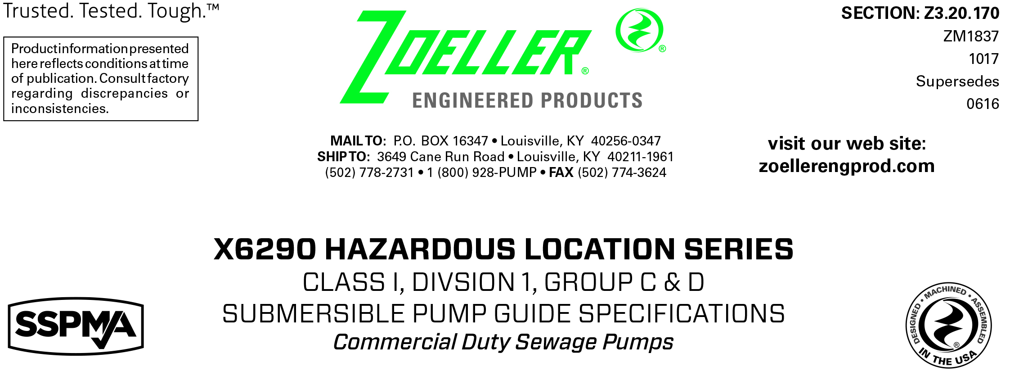
1.01 GENERAL
Contractor shall furnish all labor, material, equipment and incidentals required to provide _____ (QTY.) FM Listed and CSA Certified submersible centrifugal sewage / dewatering pump(s) with 2”solids passing vortex impeller for Class I, Division 1, and Group C & D locations as specified herein.
2.01 OPERATING CONDITIONS
Each submersible pump shall be rated at _____ H.P., _____ volts, _____ phase, _____ HZ., 3450 R.P.M. The unit shall produce _____ G.P.M. (L.P.M.) at _____ ft (m) of T.D.H.
The submersible pump shall be non-overloading throughout the length of the curve and be capable of operating unsubmerged without damaging the pump. The reserve service factor shall be a minimum of 1.15. The submersible pump shall pass a 2” spherical solid. The motor shall be rated for Class I, Division 1, and Group C & D hazardous locations. The submitted performance curve shall show the flow and head capacity of the pump.
The pump-housing configuration shall have a
___ 2.0” N.P.T. vertical discharge.
___ 3.0” N.P.T. vertical discharge.
3.01 CONSTRUCTION
Each pump shall be of the close coupled FM Listed and CSA Certified Model _________ submersible pump as manufactured by Zoeller Engineered Products of Louisville, Ky. (800-928-7867). The castings shall be constructed of class 30 cast iron with corrosion resistant powder coated epoxy finish. The motor housing shall be finned and oil-filled to dissipate heat. All external-mating parts shall be machined and sealed with Viton square rings. All fasteners exposed to the liquid shall be 300 series stainless steel. The motor shall be protected on the top side with an isolated and sealed chamber which, in the event of cord damage, will prevent moisture wicking into the motor housing. The motor shall be protected on the lower side with a tandem mechanical seal arrangement, with each seal having a separate spring assembly. A moisture detection system shall sense the presence of moisture in the pump assembly. The upper and lower ball bearings shall be capable of handling all thrust loads. The pump housing shall be of the concentric design thereby equalizing the pressure forces inside the housing, which will extend the service life of the seals and bearings. The top cap shall have a SS rigid lifting bail and a 1-½” NPT male conduit connection. Inlet screens or strainers are prohibited.
4.01 ELECTRICAL POWER CORD
The pump shall be supplied with 25’ (7.6 m) [35’ (10.7 m) _____ or 50’ (15.2 m) _____ optional] of multiconductor power cord. It shall be SO type cord capable of continued exposure to the pumped liquid. Power cord shall be sized for the rated full load amp loading of the pump in accordance with the National Electric Code. Power cable shall enter into the junction box through a compression type-sealing gland. Each conductor in the cord is individually sealed to eliminate wicking of liquids. The entire junction chamber shall be sealed off from the motor housing by through wall terminals to protect the motor from moisture.
5.01 MOTOR
The oil-filled NEMA B motor shall be FM Listed and CSA Certified for Class I, Division 1, and Group C & D locations. At maximum load, the winding temperature will not exceed 220 degrees F submerged. Since air-filled motors are not capable of dissipating heat, they shall not be considered equal. Single-phase motors shall include an integral thermal overload switch and the capacitor circuit shall be located in the pump assembly. Three phase motors shall incorporate a thermal sensor, which is connected to the motor contactor circuit in the panel.
6.01 BEARINGS AND SHAFT
An upper radial bearing and lower thrust bearing shall be required. The bearings shall be a heavy-duty single ball bearing, which are permanently lubricated by the oil, which fills the motor housing. The motor shaft shall be made of 416 SS and have a minimum diameter of .625” (15.9 mm).
7.01 SEALS
Pump shall have a dual mechanical seal configuration with the seals mounted in tandem. Each seal assembly shall have a silicon carbide / carbon lower seal and carbon / ceramic upper seal with buna-n elastomer and 316 SS spring. It shall be equal to a Crane Type 6a configuration. Double seals with a common intermediate spring shall not be considered equal.
Optional seal faces shall be
___silicon carbide / carbon — ____ Upper.
___silicon carbide / silicon carbide — ____ Lower / ____ Upper.
8.01 IMPELLER
The impeller shall be of a fully balanced cast iron vortex design. It shall be capable of passing a solid sphere of 2” (50 mm). It shall have pump out vanes located on the back shroud to keep debris away from the seal area. Attempts to improve efficiency by coating impeller shall not be acceptable.
Optional impeller shall be
___bronze vortex design
9.01 PAINTING
The pump shall have a corrosion resistant powder coated epoxy finish on all exterior surfaces of 5 mils thick. The color finish will be green.
____ Optional coating shall be double epoxy finish protecting all castings coming in contact with the liquid.
10.01 SERVICEABILITY
Components required for the repair of the pump shall be readily available within 24 hours. Components such as mechanical seals and bearings shall not be of a proprietary design and be available from local industrial supply houses. Special tools shall not be required to service the pump. A network of approved service stations shall be available nationwide.
11.01 SUPPORT
The pump shall have cast iron support legs enabling it to be a freestanding unit.
For those situations where a freestanding unit is not desired, the following support components are available.
____ Non-sparking rail system with pump suspended from a coupling base by means of a sealing plate attached to the pump.
Rail pipes are to be provided by others.
____ SS intermediate stabilizer required for rail systems used where basin depths are greater than 12 feet .
12.01 TESTING
Each pump shall run in liquid before being shipped. It shall be checked at its maximum running point for performance, amps, grounding, winding insulation, and water tightness.
____ An optional certified test based on the Hydraulic Institute or SWPA (Submersible Wastewater Pump Association) Test Standard for submersible pumps.
____ Start up services at the job site by an authorized representative of Zoeller Engineered Products shall be required. Start- up report form ZM1074 should be completed in the presence of the installers and returned to the Project Engineer or Zoeller Engineered Products.
13.01 WARRANTY
Standard warranty shall be 12 months from date of installation or 18 months from date of manufacture, whichever comes first.

