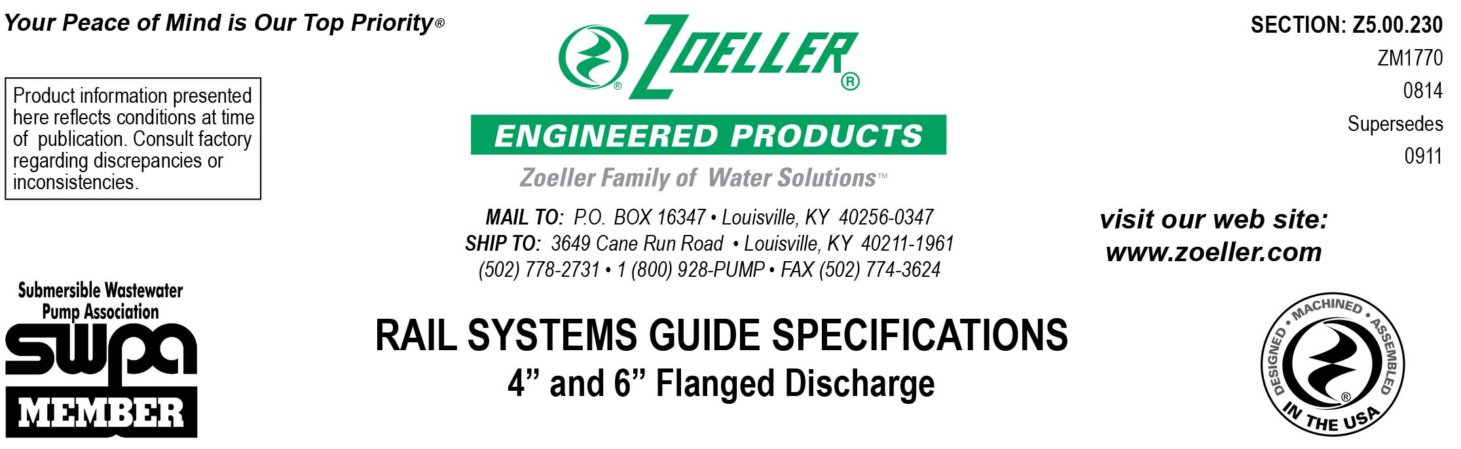

1.01
GENERAL: Contractor shall be responsible for all labor, materials, equipment and incidentals required to install a complete rail system for each pump as specified in the documents.
The rail system shall be furnished by the same manufacturer supplying the submersible pump so as to insure compatibility and assurance in matching the proper rail system with the pump being supplied and to assure single source responsibility.
The rail system shall consist of the components enabling the contractor to install the assembly in the basin. These components shall consist of the coupling base, the sealing plate with pump adapter, rail guide, and upper rail support. For basin depths greater than 15 feet, additional intermediate stabilizers shall be required. Each system will require two 2” schedule 40 SS rails, which shall be furnished by the contractor.
The configuration of the rail system pump connection and discharge shall be:
_______ 4” flanged pump connection / 4” flanged discharge pipe connection
_______ 6” flanged pump connection / 6” flanged discharge pipe connection
_______ System to be furnished with material option for non-sparking hazardous location requirements
_______ 6” rail system furnished with a #6030-0205 6” x 8” adapter fitting

2.01
CONSTRUCTION: The rail system shall be designed for concrete, steel, or fiberglass basins, which enable a pump with a horizontal
flanged discharge connection to adapt to an automatic disconnect system. When the pump is engaged with the rail system, the base
fitting shall support it in a suspended position. Rail system allowing the pump to rest on the basin floor or those that require special
proprietary sealing or bracketing shall not be acceptable.
The base shall consist of a powder-coated, epoxy cast iron stationary elbow secured to the floor of the basin with four ¾ inch bolts or rail studs (not included).
The base fitting shall include a cast iron discharge connection and rail supports.
The powder-coated, epoxy cast iron plate, mounted to the pump, shall contain an o-ring to ensure a positive seal. Rail systems having a metal to metal seating arrangement shall not be considered equal.
The rail guide, which enables to pump to slide up and down the rail pipes, shall be made of 300 series SS.
The upper rail support bracket shall be constructed of 300 series SS.
Pit depths greater than 15 feet will require an intermediate stabilizer for each additional 10 feet of rail pipe. The stabilizer shall be
constructed of 300 series SS. Refer to drawing for basin dimensional information.

3.01
ACCESSORY EQUIPMENT:
_______ SS lifting cable shall be furnished. It shall be capable of supporting 5 times the weight of the pump. The cable shall be
_____ permanently attached to / _____ removable from the pump. The cable length shall be _____ feet.
_______ Basin cover shall be furnished. It shall be configured in a manner allowing the pump(s) to be removed from the basin via rail system with no interference from the cover. Refer to the attached drawing for additional details.

The cover configuration shall be:
_______ Solid fiberglass
_______ ¼” epoxy coated steel with access hatch
_______ ¼” aluminum with access hatch rated at 300 psf
_______ H20 traffic rated

4.01
PIPING: Contractor is to furnish a pair of 2 inch schedule 40 SS rail pipes for each rail system. These pipes are to be cut to the
proper length to interface with the coupling base and upper rail support. The system(s) shall be positioned in such a way as to enable the operator to automatically remove the pump, without entering the basin, as shown in the drawings.
Pump discharge piping shall include a suitable check valve and shut-off valve for each pump as shown in the drawing. All pipe and
fittings shall be corrosion resistant. Where piping passes through the wall of the basin, it shall be sealed with a watertight joint or fitting.

