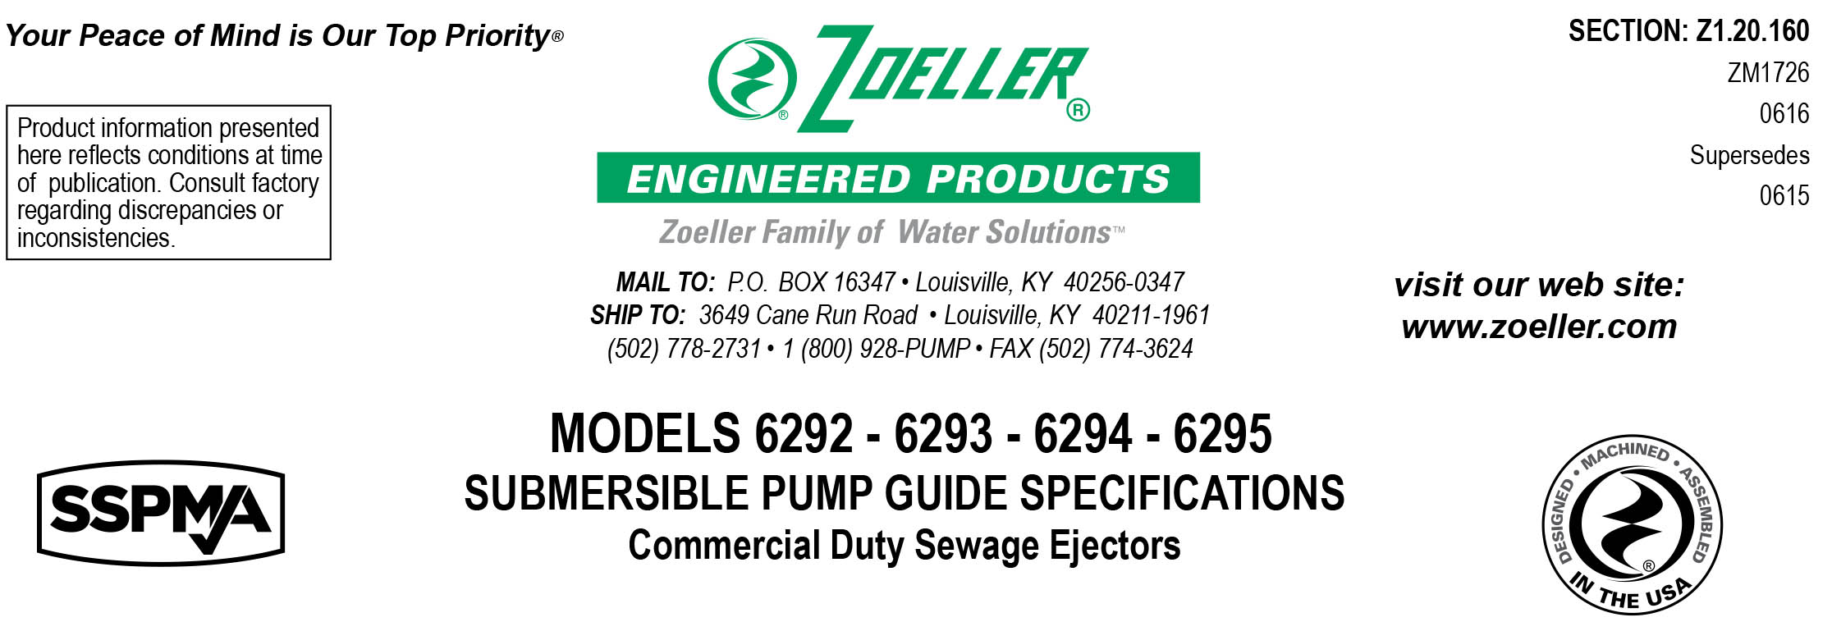
1.01 GENERAL:
Contractor shall furnish all labor, material, equipment and incidentals required to provide _________ (QTY.)
MODEL _______ submersible centrifugal 2” (50 mm) solids handling pump(s) with vortex impeller as specified herein.

2.01 OPERATING CONDITIONS
Each submersible pump shall be rated at _____ H.P., _____ volts, _____ phase, _____ HZ., 3450 R.P.M. The unit shall produce ________ G.P.M. at _____ feet of T.D.H.

The submersible pump shall be non-overloading throughout the length of the curve and be capable of operating not submerged without damaging the pump. The reserve service factor shall be a minimum of 1.15. The submersible pump shall pass a 2.0” (50 mm) spherical solid. The submitted performance curve shall show the flow and head capacity of the pump.

The pump housing configuration shall have a
___ 2.0” N.P.T. vertical discharge.
___ 3.0” N.P.T. vertical discharge.

3.01 CONSTRUCTION
Each pump shall be of the close coupled U.L. and/or cCSAus listed Model _________ submersible pump as manufactured by Zoeller Engineered Products of Louisville, Ky. (800-928-7867). The castings shall be constructed of epoxy coated class 30 cast iron. The motor housing shall be finned and oil-filled to dissipate heat. All external-mating parts shall be machined and sealed with a viton square ring. All fasteners exposed to the liquid shall be 300 series stainless steel. The motor shall be protected on the top side with an attached sealed junction box chamber which in the event of cord damage will prevent moisture entering the motor housing. The motor shall be protected on the lower side with a tandem mechanical seal arrangement with each seal having a separate spring assembly. The upper and lower ball bearings shall be capable of handling all thrust loads. The pump housing shall be of the concentric design thereby equalizing the pressure forces inside the housing which will extend the service life of the seals and bearings. The top cap shall have a SS lifting handle.

As an optional feature include ___ seal leak probes in the seal chamber.

4.01 ELECTRICAL POWER CORD
The pump shall be supplied with ____ 25’ (7.6 m) / ____ 35’ (10.7 m) / ____ 50’ (15.2 m) of multiconductor power cord. It shall be SO type cord capable of continued exposure to the pumped liquid. Power cord shall be sized for the rated full load amp loading of the pump in accordance with the National Electric Code. Power cable shall enter into the junction box through a compression type-sealing gland. Water sealing and strain relief are separated. The entire junction chamber shall be sealed off from the motor housing by thru wall terminals to protect the motor from moisture.

5.01 MOTOR
The motor shall be an oil filled NEMA B design. At maximum load, the winding temperature will stabilize below the insulation class. Since air-filled motors are not capable of dissipating heat, they shall not be considered equal. Single-phase motors shall include an integral thermal overload switch and the capacitor circuit shall be located in the pump assembly. Three phase motors shall use magnetic starters with overload relays in the control panel for further protection.

6.01 BEARINGS AND SHAFT
The upper and lower ball bearing are continually lubricated by the oil which fills the motor housing. The motor shaft shall be made of 416 SS and have a minimum diameter of .625” (15.9 mm).

7.01 SEALS
Pump shall have a dual mechanical seal configuration with the seals mounted in tandem. The lower silicon carbide / carbon and upper carbon / ceramic seals are constructed with buna-n elastomers and a 316 SS spring. It shall be equal to a Crane Type 6a configuration. Double seals with a common intermediate spring shall not be considered equal.

Optional seal faces shall be
____ Silicon carbide / carbon ____ Upper.
____ Silicon carbide / silicon carbide — ____ Lower / ____ Upper.

8.01 IMPELLER
The impeller shall be of a fully balanced cast iron vortex design. It shall be capable of passing a solid sphere of 2.0” (50 mm) under the impeller. It shall have pump out vanes located on the back shroud to keep debris away from the seal area. Attempts to improve efficiency by coating impeller shall not be acceptable.

Optional impeller shall be
____ Bronze vortex design

9.01 PAINTING
The castings shall be protected with a green powder-coated finish.

Optional coating shall be
____ double epoxy finish protecting all castings coming in contact with the liquid.

10.01 SERVICEABILITY
Components required for the repair of the pump shall be readily available within 24 hours. Components such as mechanical seals and bearings shall not be of a proprietary design and be available from local industrial supply houses. Special tools shall not be required to service the pump. A network of service stations shall be available nationwide in those cases where service requirements are beyond the scope of in-house service mechanics.

11.01 SUPPORT
The pump shall have cast iron support legs enabling it to be a freestanding unit.

When ground level access and retrieval is preferred, the following system is available.
____ The Z-Rail® disconnect system, consisting of an epoxy coated ductile iron disconnect fitting, slide assembly and
upper rail support. Rail pipes and lifting cables are not included.
____ SS intermediate stabilizer required for rail systems used where basin depths are greater than 12 feet (3.6 m).

For those “Outdoor” installations requiring a factory assembled basin package:
____ Simplex system with a ____ diameter by ____ depth basin.
____ Duplex system with a ____ diameter by ____ depth basin.

12.01 TESTING
Each pump shall run in liquid before being shipped. It shall be checked at its maximum running point for performance, amps, grounding, winding insulation, and water tightness.

____ An optional certified performance test based on the Hydraulic Institute Test Standard for submersible pumps.

____ Start up services at the job site by an authorized representative of Zoeller Engineered Products shall be required.
Start-up report form ZM1074 should be completed in the presence of the installers and returned to the Project
Engineer or Zoeller Engineered Products.

13.01 WARRANTY
Standard warranty shall be 12 months from date of installation or 18 months from date of manufacture, whichever comes first.

